#### 

### **A CRM APPLICATION TO ENGINEERING WORKS**

**Category :** Salesforce

**Skill Required:** Salesforce Developer

**Introduction**

Customer Relationship Management (CRM) systems have revolutionized how companies interact with their customers, streamline operations, and increase productivity. A CRM tailored for managing engineering works can provide real-time insights into project details, client interactions, and material management, thus enhancing overall project efficiency. For engineering companies that deal with fabrication, shed construction, and pipe lining, managing client data and project workflows is critical. This project focuses on building a Salesforce-based CRM application that will help manage client and project information, track materials and processes, and automate cost calculation, offering a seamless experience for project managers and clients alike.

**Overview of salesforce:** Salesforce is a cloud-based software platform that provides comprehensive CRM solutions to manage customer relationships, sales processes, and enterprise operations. Salesforce enables businesses to integrate various data and functions into a single platform, enhancing productivity, collaboration, and decision-making. As a Salesforce Developer, you can customize and build applications on the Salesforce platform using tools such as Apex (Salesforce's programming language), Visualforce (for creating custom user interfaces), and Lightning components. Salesforce also includes tools for reporting, analytics, and automation to ensure smooth business operations.

**Key features supporting the project**

**1. Client Management:**

* Store detailed information about clients, including company name, owner details, contact info, and project requirements.
* Maintain a historical record of all client interactions and project milestones.

**2. Project and Work Tracking:**

* Categorize different types of engineering works such as fabrication, shed construction, and pipe lining.
* Track specific tasks within each category, such as drilling, welding, cutting, folding, construction, and pipe repairs or replacements.
* Monitor work progress and assign tasks to workers.

**3. Material and Measurement Management:**

* Maintain an inventory of materials required for each project.
* Track material usage based on project measurements and requirements.
* Automatically calculate the price based on material type, quantity, and dimensions.

**4. Cost Estimation and Automation:**

* Utilize Salesforce’s automation tools to calculate costs dynamically based on material measurements, labor, and processes involved.
* Generate quotes and invoices for clients based on predefined formulas and workflows.

**5. Task Automation:**

* Automate various workflows, such as sending notifications when a task is completed or when materials need to be reordered.
* Use Salesforce’s Process Builder or Flow to create automated processes, such as reminders for project deadlines or follow-ups with clients.

**6. Reporting and Dashboards:**

* Create custom reports and dashboards to track project progress, material costs, and financial metrics.
* Visualize key performance indicators (KPIs) related to client satisfaction, worker efficiency, and cost management.

**7. User Roles and Permissions:**

* Define user roles for various stakeholders (e.g., Project Manager, Worker, Admin) with different levels of access to data and features.
* Ensure that sensitive client and project information is securely stored and accessible only to authorized users.

**Project Overview**

This CRM application will be built on the Salesforce platform, leveraging its capabilities to manage client information, project workflows, and material requirements. The goal is to provide an efficient system for tracking client details, managing engineering tasks, calculating costs, and automating key processes. The application will have a user-friendly interface to facilitate easy data entry and retrieval, with real-time updates and alerts for project managers and clients.

**Project Breakdown:**

* **Client Information:** Detailed records of client company information, contact persons, and their specific project needs.
* **Engineering Work Categories:** Fabrication (drilling, welding, cutting, folding), Shed Construction, and Pipe Lining (pipe repairing and replacing).
* **Materials and Measurements:** Ability to input material types, measurements, and automatically calculate the total price for each project.
* **Task Management:** Assign tasks to workers and track project milestones.
* **Automated Workflows:** Automation of cost estimation, project updates, and client notifications.
* **Reporting and Dashboards:** Creation of custom reports to visualize project progress and performance metrics.

**Goals for the Project**

1. **Improve Efficiency:**
   * Streamline the management of engineering projects by centralizing client, material, and project data into one CRM system.
   * Reduce manual calculations and paperwork by automating cost calculations and task assignments.
2. **Enhance Communication:**
   * Improve communication between project managers, clients, and workers by providing a platform where all project information is accessible in real-time.
   * Provide clients with updates and status reports automatically, keeping them informed on project progress.
3. **Optimize Project Tracking:**
   * Enable project managers to track tasks, milestones, and deadlines for each engineering work, ensuring that all processes are completed on time.
   * Use Salesforce’s tracking and reporting tools to ensure transparency and accountability across the project lifecycle.
4. **Cost Management and Profitability:**
   * Accurately calculate the total cost of materials, labor, and other resources based on project specifications.
   * Ensure profitability by providing the ability to adjust pricing models based on client requirements and material costs.
5. **Customization and Scalability:**
   * Build a flexible and customizable platform that can be adapted to different types of engineering works and client needs.
   * Ensure scalability so that the application can grow with the company as it takes on more clients and projects.
6. **User-Centric Design:**
   * Design an intuitive and easy-to-use interface that minimizes the learning curve for users.
   * Ensure that the system is accessible to all user roles (clients, project managers, and workers) with appropriate permissions and access.

**Detailed Description of Implemented Features:**

**Salesforce Developer Account Creation**

* To sign up for a salesforce account
* To login to your salesforce account
* Account activation

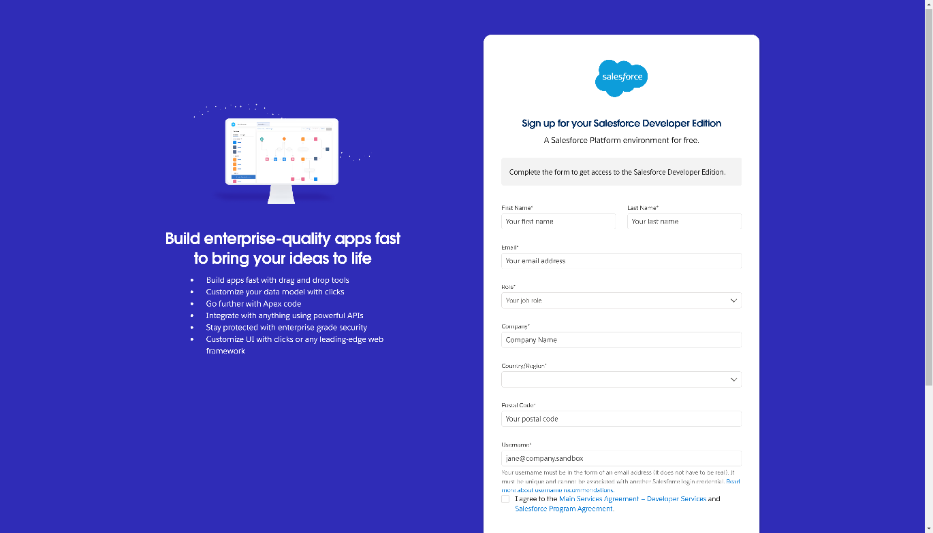

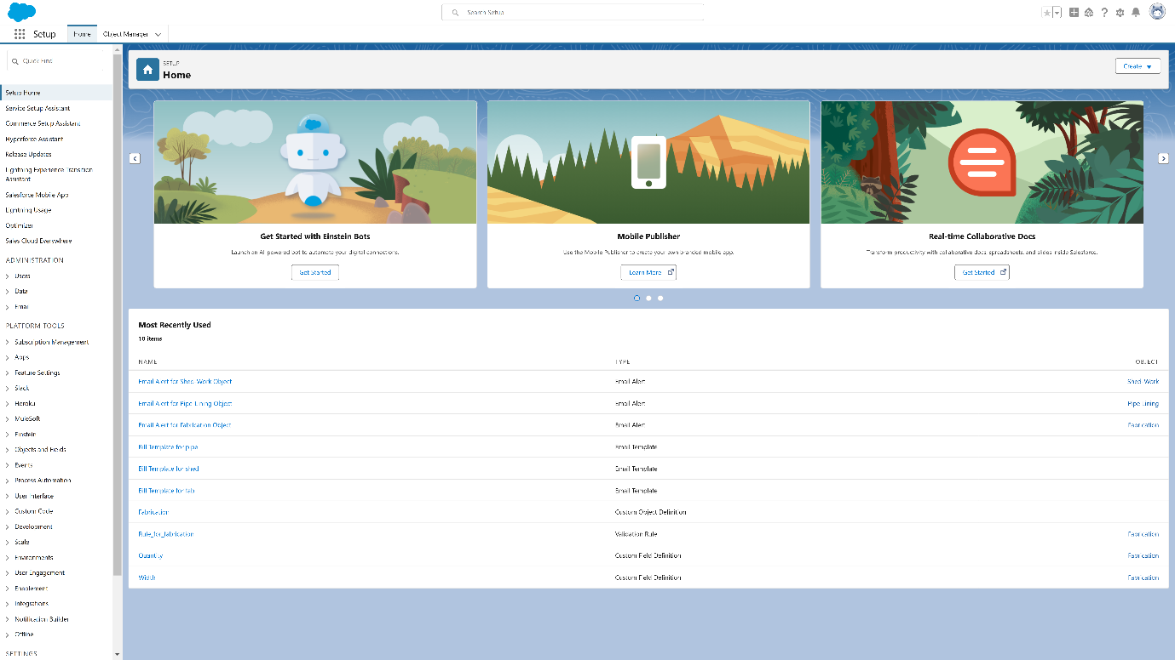

**Object Creation**

**Fabrication:**

This object tracks all aspects of the fabrication work in the project, including specific tasks like drilling, welding, cutting, and folding. It helps manage the workflows and materials required for various fabrication processes, ensuring each task is tracked and completed on time.

**To create an object:**

From the setup page >> Click on Object Manager >> Click on Create >>Click on Custom Object.

1. Enter the label name>> Fabrication
2. Plural label name >> Fabrications
3. Enter Record Name Label and Format

• Record Name >> Fabrication Name

• Data Type >> Text

1. Click on Allow reports and Track Field History, Allow Activities
2. Allow search >> Save.

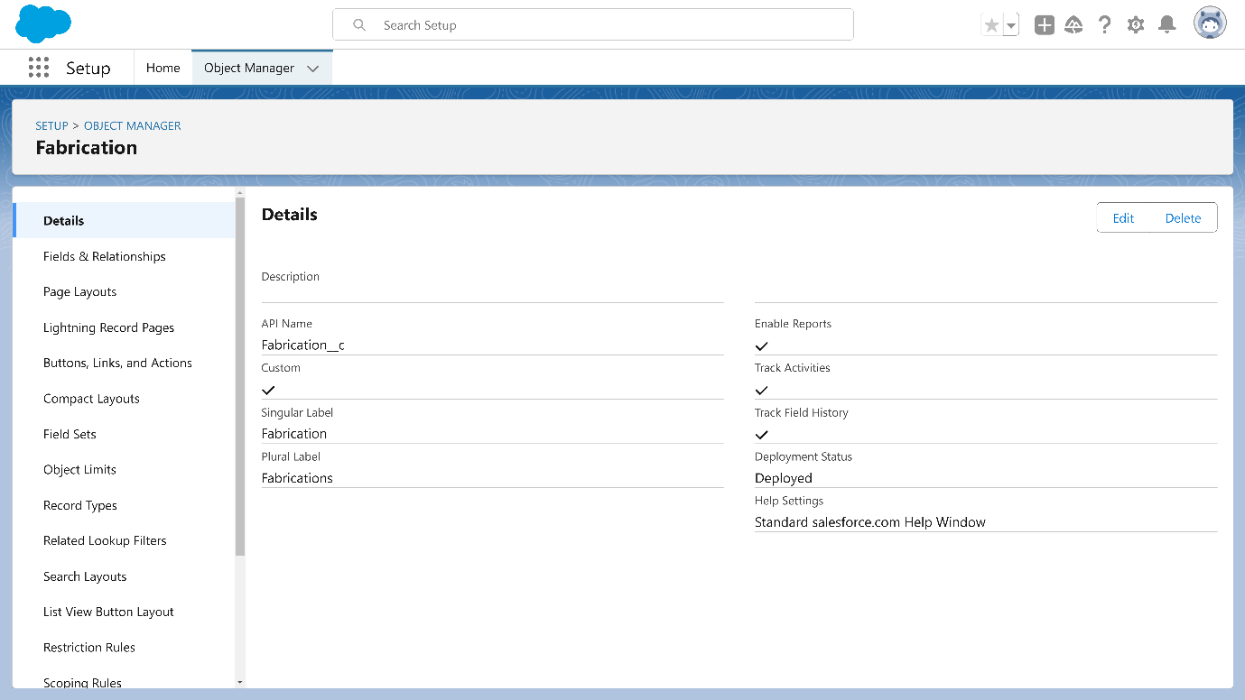

**Shed-Work:**

This object focuses on managing tasks related to shed construction. It includes tracking the types of sheds being built, the materials used, and the timeline for each phase of construction, helping project managers monitor progress and resources efficiently.

**To create an object:**

From the setup page >> Click on Object Manager >> Click on Create >> Click on Custom Object.

1. Enter the label name >> Shed-Work
2. Plural label name >> Shed Works
3. Enter Record Name Label and Format

• Record Name >> Shed Work Name

• Data Type >> Text

1. Click on Allow reports and Track Field History, Allow Activities
2. Allow search >> Save.

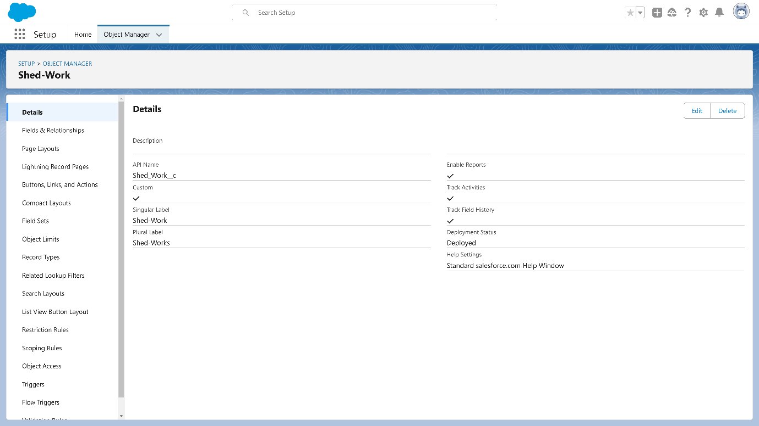

**Pipe Lining:** The Pipe Lining object handles all aspects of pipe repair and replacement. It includes data on the condition of the pipes, the materials needed for repairs, and the timeline for replacement or maintenance, ensuring the project stays on schedule and within budget.

**To create an object:**

From the setup page >> Click on Object Manager>> Click on Create >> Click on Custom Object.

1. Enter the label name >> Pipe Lining
2. Plural label name >> Pipe Linings
3. Enter Record Name Label and Format

• Record Name >> Pipe Lining Name

• Data Type >> Text

1. Click on Allow reports and Track Field History, Allow Activities
2. Allow search >> Save.

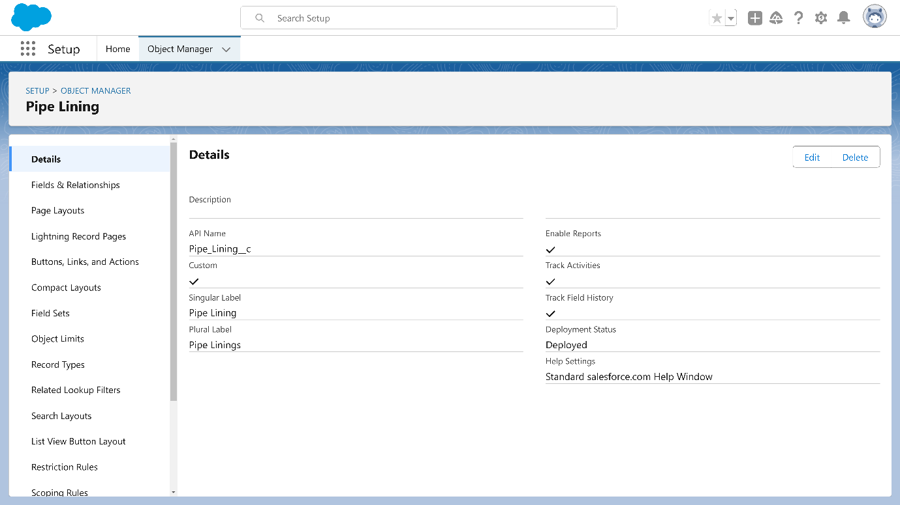

**Worker**: The Worker object manages the details of each worker involved in the engineering projects. It includes personal information, skills, assigned tasks, and work hours, allowing project managers to track worker productivity and ensure resource allocation is optimized across all tasks.

**To create an object:**

From the setup page >> Click on Object Manager>> Click on Create >> Click on Custom Object.

1. Enter the label name >> Worker
2. Plural label name >> Workers
3. Enter Record Name Label and Format

* Record Name >> Worker Name
* Data Type >> Text

1. Click on Allow reports and Track Field History, Allow Activities
2. Allow search >> Save.

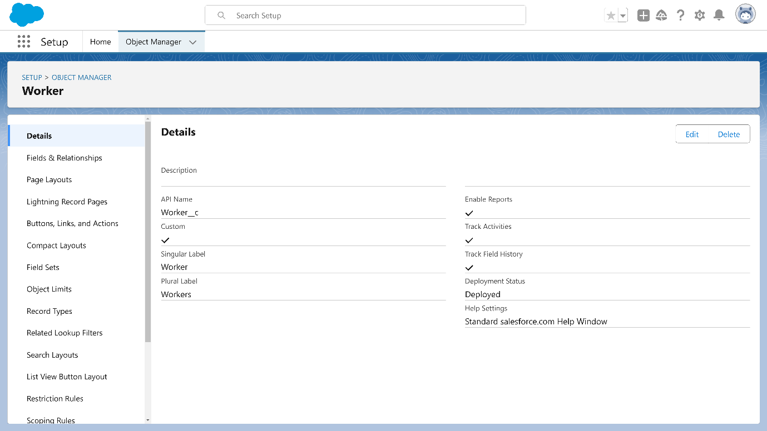

**Tabs**

**Fabrication Tab**

* Purpose: Displays and manages all fabrication-related tasks and projects.
* Data Fields:
  + Fabrication ID: Unique identifier for each fabrication project.
  + Project Name: Name or title of the fabrication project.
  + Client Name: Associated client for the fabrication work.
  + Processes Involved: List of specific tasks (e.g., drilling, welding, cutting, folding).
  + Materials Used: Details of materials required, including type, quantity, and specifications.
  + Estimated Cost: Automated calculation based on materials and processes.
  + Status: Current status of the fabrication task (e.g., In Progress, Completed).
  + Start and End Dates: Timeline for project initiation and completion.

**2. Shed-Work Tab**

* Purpose: Manages information on shed construction projects.
* Data Fields:
  + Shed-Work ID: Unique identifier for each shed construction project.
  + Project Name: Name of the specific shed construction work.
  + Client Name: Name of the client commissioning the work.
  + Type of Shed: Information on the type of shed (e.g., industrial, residential).
  + Materials Used: Materials required for shed construction, including specifications and measurements.
  + Labor Hours: Estimated or actual labor hours needed for construction.
  + Cost Estimation: Automatically calculated cost based on materials and labor.
  + Progress Status: Current project status (e.g., Not Started, In Progress, Completed).
  + Project Timeline: Projected start and end dates.

**3. Pipe Lining Tab**

* Purpose: Manages pipe lining and related repair projects.
* Data Fields:
  + Pipe Lining ID: Unique identifier for each pipe lining project.
  + Project Name: Specific name or title for the pipe lining work.
  + Client Name: Name of the client requesting the work.
  + Type of Repair: Description of the pipe repair or replacement type.
  + Materials Required: List and quantity of materials needed (e.g., pipe sizes, fittings).
  + Estimated Cost: Cost calculation based on materials and labor.
  + Current Status: Status of the pipe lining project (e.g., Awaiting Approval, In Progress).
  + Duration: Project timeline with start and estimated completion dates.
  + Assigned Worker(s): Worker(s) assigned to the project.

**4. Worker Tab**

* Purpose: Manages data related to workers involved in various engineering projects.
* Data Fields:
  + Worker ID: Unique identifier for each worker.
  + Name: Full name of the worker.
  + Role: Worker’s role (e.g., Welder, Driller, Supervisor).
  + Skill Set: List of skills (e.g., welding, drilling, cutting) the worker has.
  + Current Project: Project(s) currently assigned to the worker.
  + Hours Worked: Daily or weekly hours worked on projects.
  + Contact Information: Worker’s phone number and email for communication.
  + Status: Availability status (e.g., Available, On Leave, Busy).
  + Project History: List of past projects with details on their roles and performance.

Each of these tabs will allow users to access and manage specific aspects of the project workflow, helping streamline the CRM processes for engineering works in fabrication, shed construction, and pipe lining.

**Creation of Custom tabs**

To create a Tab:( Fabrication)

1. Go to setup page >> type Tabs in Quick Find bar >> click on tabs >> New (under custom object tab)
2. Select Object(Fabrication) >> Select the tab style >> Next (Add to profiles page) keep it as default >> Next (Add to Custom App)  uncheck the include tab .
3. Make sure that the Append tab to users' existing personal customizations is checked.
4. Click save

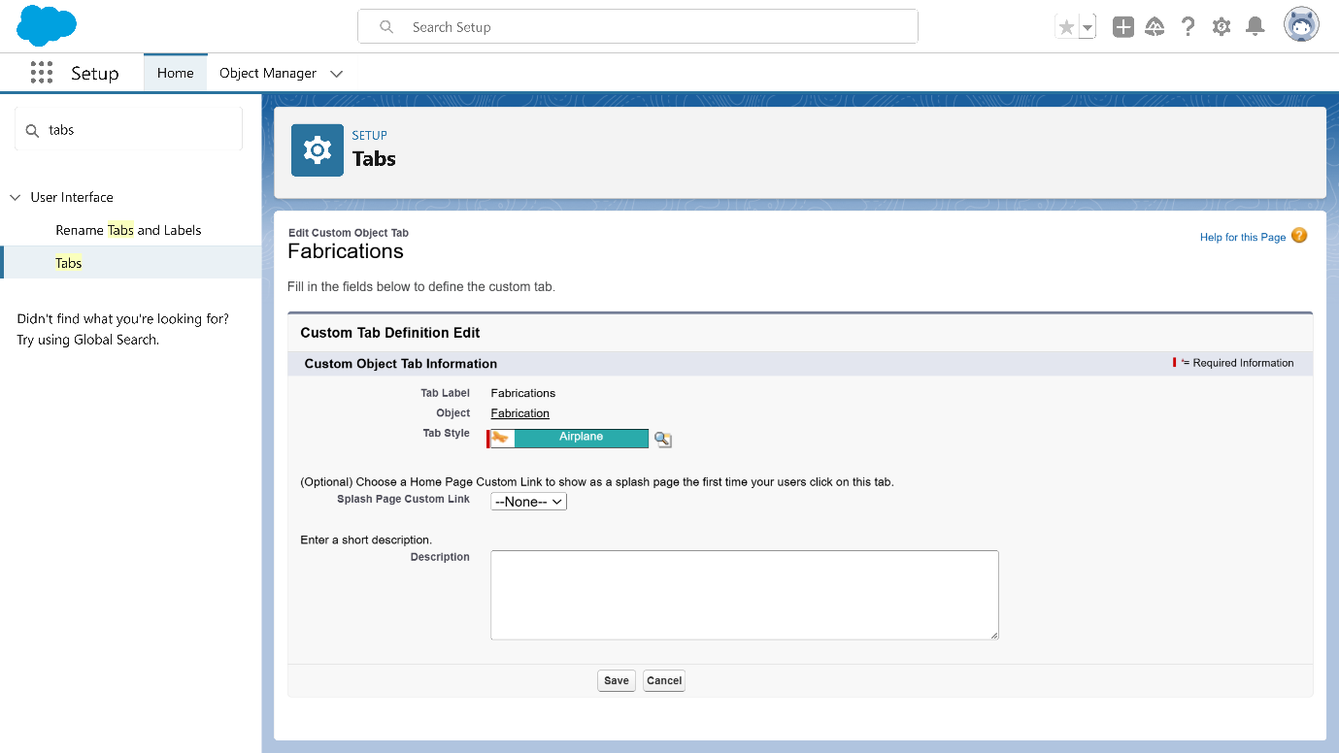

To create a Tab:( Shed-work)

1. Go to setup page >> type Tabs in Quick Find bar >> click on tabs >> New (under custom object tab)
2. Select Object(Shed-Work) >> Select the tab style >> Next (Add to profiles page) keep it as default >> Next (Add to Custom App)  uncheck the include tab .
3. Make sure that the Append tab to users' existing personal customizations is checked.
4. Click save

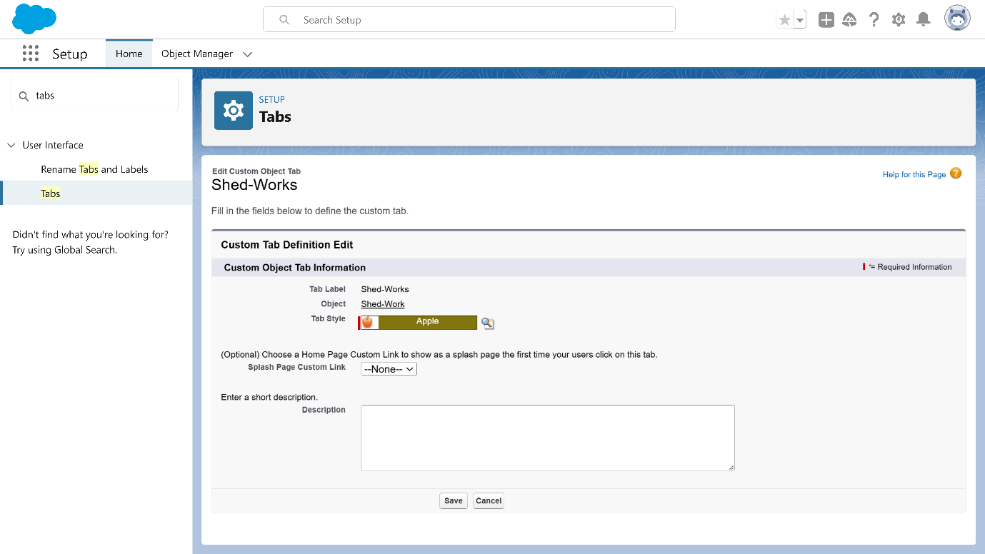

To create a Tab:( Pipe Lining)

1. Go to setup page >> type Tabs in Quick Find bar >> click on tabs >> New (under custom object tab)
2. Select Object(Pipe Lining) >> Select the tab style >> Next (Add to profiles page) keep it as default >> Next (Add to Custom App)  uncheck the include tab .
3. Make sure that the Append tab to users' existing personal customizations is checked.
4. Click save

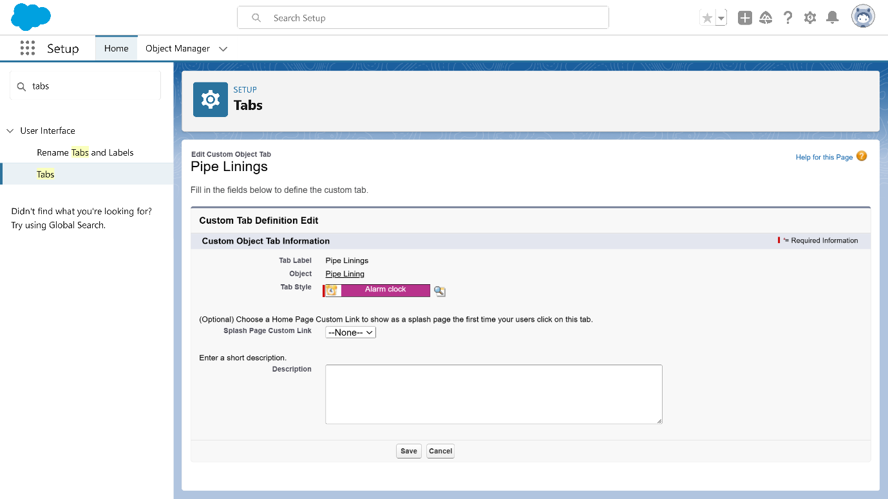

To create a Tab:( Worker)

1. Go to setup page >> type Tabs in Quick Find bar >> click on tabs >> New (under custom object tab)
2. Select Object(Worker) >> Select the tab style >> Next (Add to profiles page) keep it as default >> Next (Add to Custom App)  uncheck the include tab .
3. Make sure that the Append tab to users' existing personal customizations is checked.
4. Click save

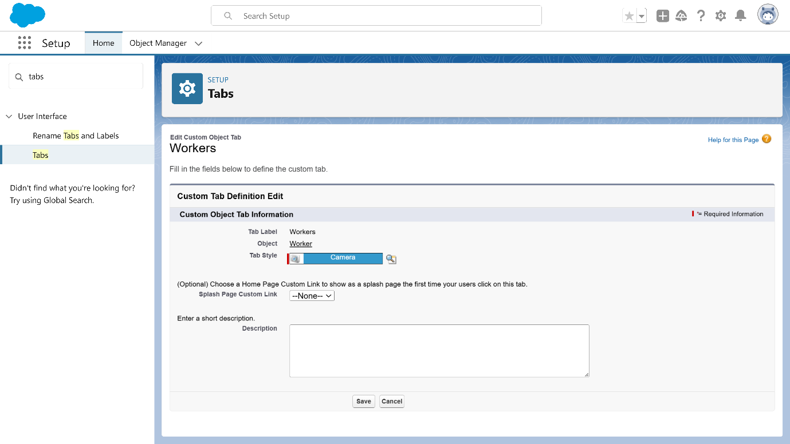

**Lightning apps**

**Creation of lightning apps**

**Steps to Create a Lightning App Page**

1. **Access App Manager**
   * Go to Setup page.
   * In the Quick Find search bar, type “App Manager” and select it from the options.
   * Click on New Lightning App.
2. **App Details and Branding**
   * Fill in the following details:
     + App Name: *Engineering Works*
     + Developer Name: Auto-populated.
     + Image: Optional; upload if desired.
     + Primary Color Hex Value: Keep it as default.
   * Click Next to continue.
3. **App Options**
   * Set Navigation Style as Standard Navigation.
   * Click Next.
4. **Utility Items**
   * Leave the settings as default.
   * Click Next.
5. **Add Navigation Items**
   * In the search bar, look up and add items in the following order:
     + *Fabrications*
     + *Shed Works*
     + *Pipe Linings*
     + *Workers*
   * Use the arrow button to move each item to the selected list.
   * Click Next.
6. **Add User Profiles**
   * Search for *System Administrator* in the profiles search bar.
   * Select it by clicking the arrow button.
   * Click Save & Finish.

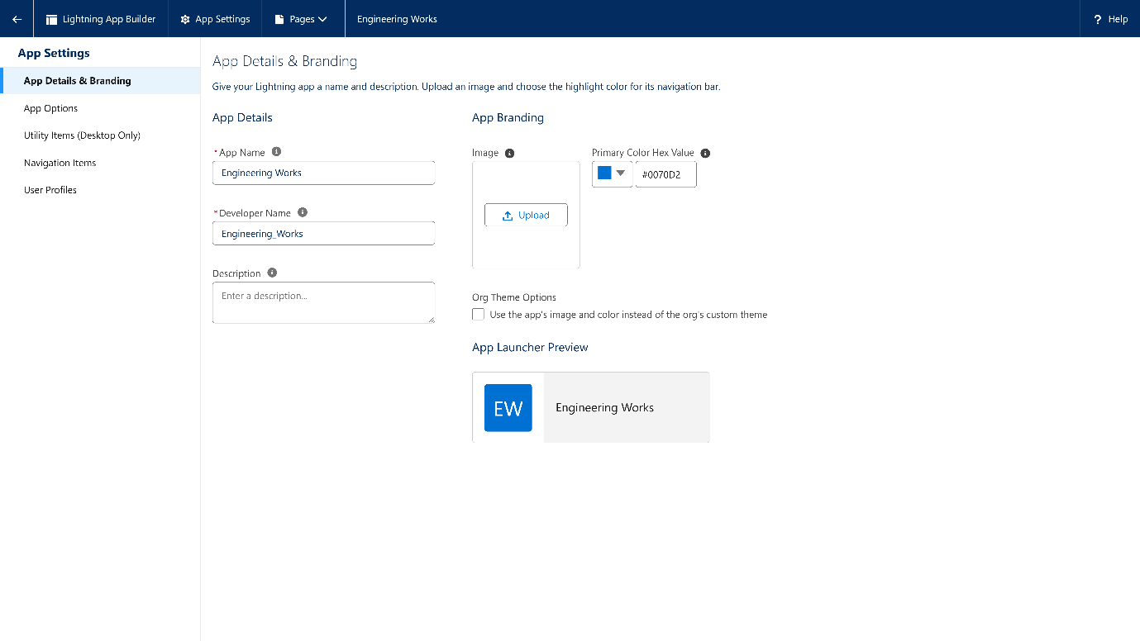

**Fields**

**Steps to Create Fields in Fabrication Object**

1. **Access Fabrication Object**
   * Go to **Setup** > **Object Manager**.
   * Search and select **Fabrication**.
   * Go to **Fields & Relationships** > **New**.
2. **Add Fields**  
   Follow these settings for each field:
   * **Field 1: Name of the Owner**
     + **Type**: Text
     + **Field Label**: Name of the Owner
     + **Length**: 125
     + **Required**: Checked
   * **Field 2: Name of Company**
     + **Type**: Text
     + **Field Label**: Name of Company
   * **Field 3: Length**
     + **Type**: Number
     + **Field Label**: Length
     + **Length**: 16, **Decimal Places**: 2
     + **Required**: Checked
   * **Field 4: Breadth**
     + **Type**: Number
     + **Field Label**: Breadth
     + **Length**: 16, **Decimal Places**: 2
     + **Required**: Checked
   * **Field 5: Width**
     + **Type**: Number
     + **Field Label**: Width
     + **Length**: 16, **Decimal Places**: 2
     + **Required**: Checked
   * **Field 6: Area**
     + **Type**: Formula (Number)
     + **Formula**: Length__c * Breadth__c * Width__c
   * **Field 7: Cost per Meter**
     + **Type**: Number
     + **Field Label**: Cost per Meter
     + **Default Value**: 2
     + **Read Only**: Checked
   * **Field 8: Quantity**
     + **Type**: Number
     + **Length**: 16, **Decimal Places**: 2
     + **Required**: Checked
   * **Field 9: Amount**
     + **Type**: Formula (Currency)
     + **Formula**: Area__c * Cost_per_meter__c * Quantity__c
   * **Field 10: Material Type**
     + **Type**: Picklist
     + **Values**: Iron, Aluminum, Metal, Wood, Steel
   * **Field 11: Final Price**
     + **Type**: Currency
   * **Field 12: Email**
     + **Type**: Email
3. **Save Each Field**
   * For each field, proceed through **Next > Next > Save** (use **Save and New** for additional fields).

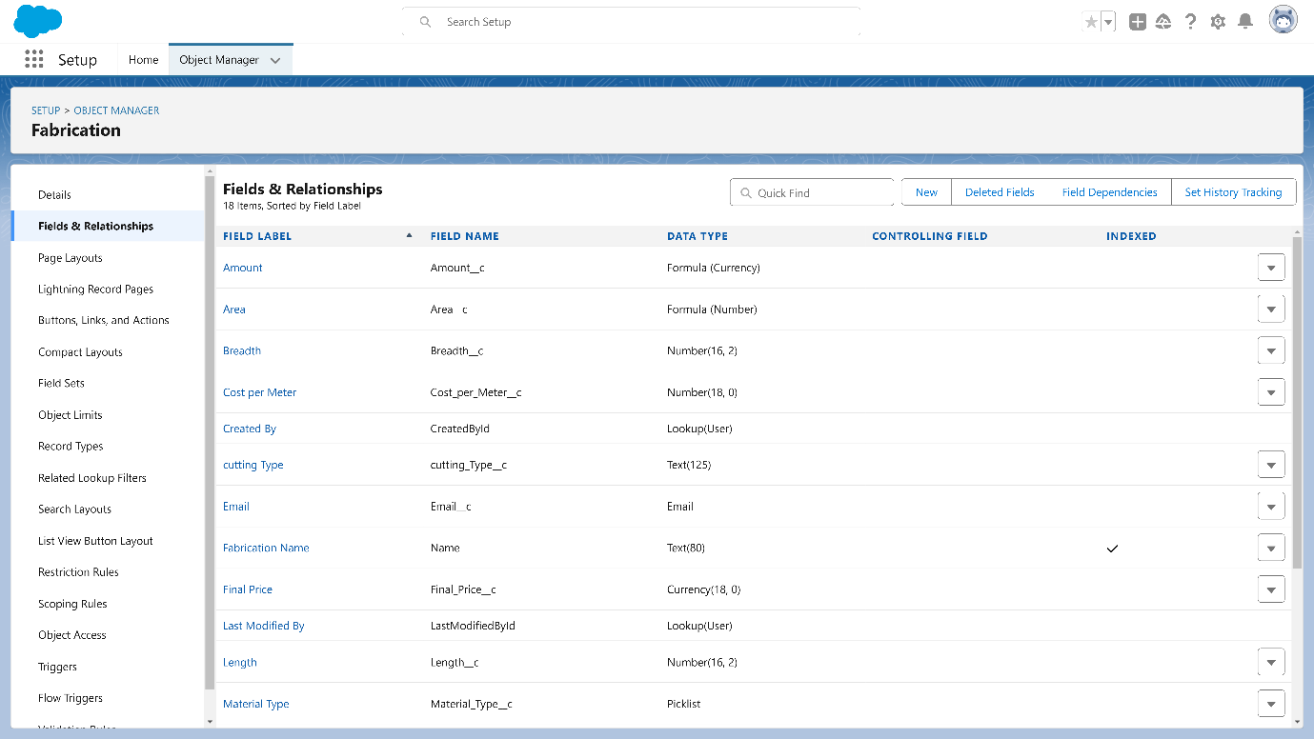

**Steps to Create Fields in Shed-Work Object**

1. **Access Shed-Work Object**
   * Go to **Setup** > **Object Manager**.
   * Search and select **Shed-Work**.
   * Navigate to **Fields & Relationships** > **New**.
2. **Add Fields**  
   For each field, proceed through **Next > Next > Save and New** (or **Save** if final field).
   * **Field 1: Name of the Company**
     + **Type**: Text
     + **Required**: Checked
   * **Field 2: Name of the Owner**
     + **Type**: Text
     + **Required**: Checked
   * **Field 3: Height**
     + **Type**: Number
     + **Length**: 16, **Decimal Places**: 2
     + **Required**: Checked
   * **Field 4: Breadth**
     + **Type**: Number
     + **Length**: 16, **Decimal Places**: 2
     + **Required**: Checked
   * **Field 5: Width**
     + **Type**: Number
     + **Length**: 16, **Decimal Places**: 2
     + **Required**: Checked
   * **Field 6: Area**
     + **Type**: Formula (Number)
     + **Formula**: Height__c * Breadth__c * Width__c
   * **Field 7: Area Sheet**
     + **Type**: Formula (Number)
     + **Formula**: Height__c * Breadth__c
   * **Field 8: Cost per Meter**
     + **Type**: Number
     + **Default Value**: 2
     + **Read Only**: Checked
   * **Field 9: Quantity**
     + **Type**: Number
     + **Length**: 16, **Decimal Places**: 2
     + **Required**: Checked
   * **Field 10: Cost per Meter Sheet**
     + **Type**: Number
     + **Default Value**: 2
     + **Read Only**: Checked
   * **Field 11: Amount**
     + **Type**: Formula (Currency)
     + **Formula**: Area__c * Cost_per_meter__c * Quantity__c
   * **Field 12: Amount Sheet**
     + **Type**: Formula (Currency)
     + **Formula**: Cost_per_meter_sheet__c * Area_Sheet__c * Quantity__c
   * **Field 13: Material Type**
     + **Type**: Picklist
     + **Values**: Iron, Metal, Steel
   * **Field 14: Material Type Sheet**
     + **Type**: Picklist
     + **Values**: Plastic, Metal, Rubber
   * **Field 15: Final Price**
     + **Type**: Currency
   * **Field 16: Email**
     + **Type**: Email

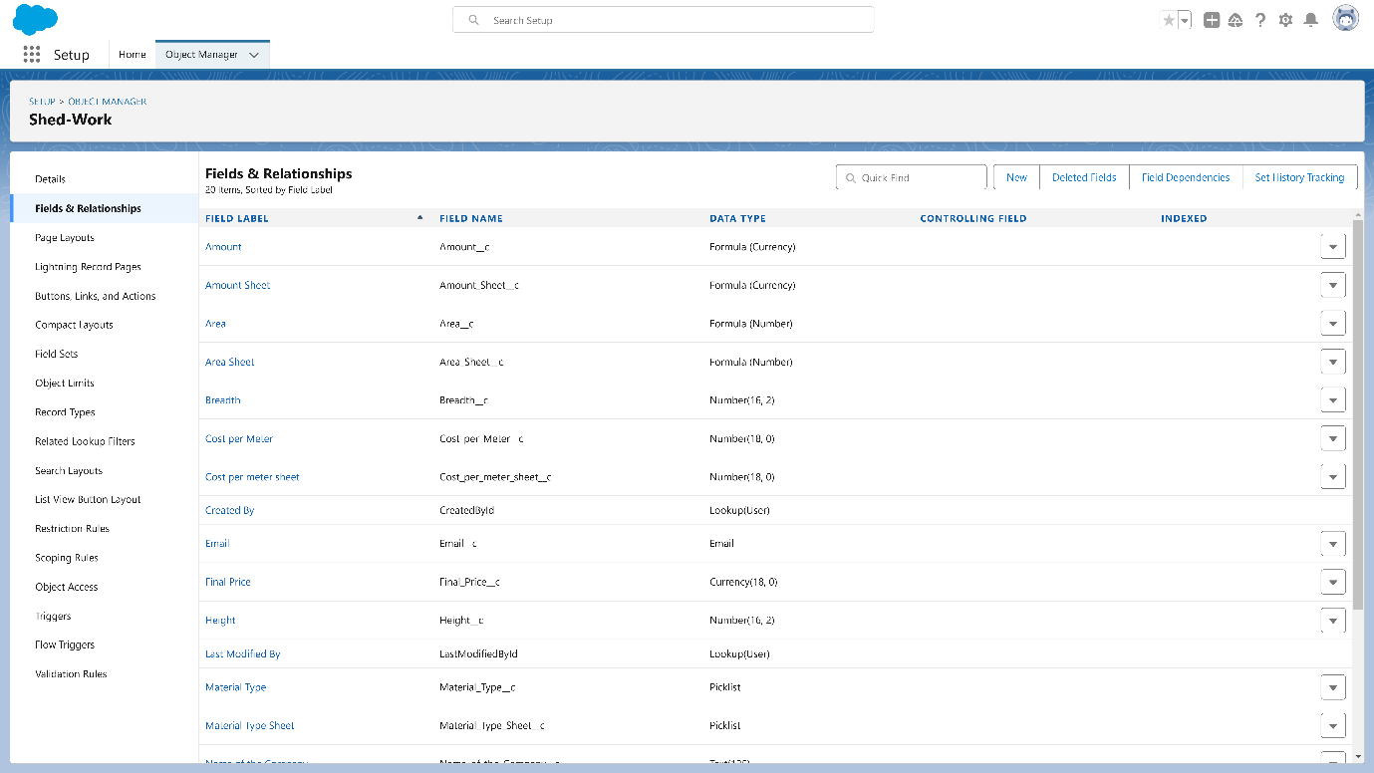

### Steps to Create Fields in Pipe Lining Object

1. **Access Pipe Lining Object**
   * Go to **Setup** > **Object Manager**.
   * Search and select **Pipe Lining**.
   * Navigate to **Fields & Relationships** > **New**.
2. **Add Fields**  
   For each field, proceed through **Next > Next > Save and New** (or **Save** if final field).
   * **Field 1: Name of the Company**
     + **Type**: Text
     + **Required**: Checked
   * **Field 2: Name of the Owner**
     + **Type**: Text
     + **Required**: Checked
   * **Field 3: Height**
     + **Type**: Number
     + **Length**: 16, **Decimal Places**: 2
     + **Required**: Checked
   * **Field 4: Width**
     + **Type**: Number
     + **Length**: 16, **Decimal Places**: 2
     + **Required**: Checked
   * **Field 5: Diameter**
     + **Type**: Number
     + **Length**: 16, **Decimal Places**: 2
     + **Required**: Checked
   * **Field 6: Area**
     + **Type**: Formula (Number)
     + **Formula**: PI() * Height__c * Diameter__c
   * **Field 7: Cost per Meter**
     + **Type**: Number
     + **Default Value**: 2
     + **Read Only**: Checked
   * **Field 8: Quantity**
     + **Type**: Number
     + **Length**: 16, **Decimal Places**: 2
     + **Required**: Checked
   * **Field 9: Amount**
     + **Type**: Formula (Currency)
     + **Formula**: Area__c * Cost_per_meter__c * Quantity__c
   * **Field 10: Material Type**
     + **Type**: Picklist
     + **Values**: Iron, Metal, Aluminum
   * **Field 11: Final Price**
     + **Type**: Currency
   * **Field 12: Email**
     + **Type**: Email



**Steps to Create Fields in Worker Object**

1. **Access Worker Object**
   * Go to Setup > Object Manager.
   * Search and select Worker.
   * Navigate to Fields & Relationships > New.
2. **Add Fields**For each field, proceed through Next > Next > Save and New (or Save if final field).
   * **Field 1:** Worker Name
     + Type: Text
     + Length: 125
   * **Field 2:** Phone Number
     + Type: Number
     + Length: 10
     + Required: Checked
   * **Field 3:** Designation
     + Type: Picklist
     + Values:
       - Accountant
       - Welder
       - Driller
       - Pitter
       - Manager
   * **Field 4:** Salary
     + Type: Currency
     + Length: 10
     + Required: Checked

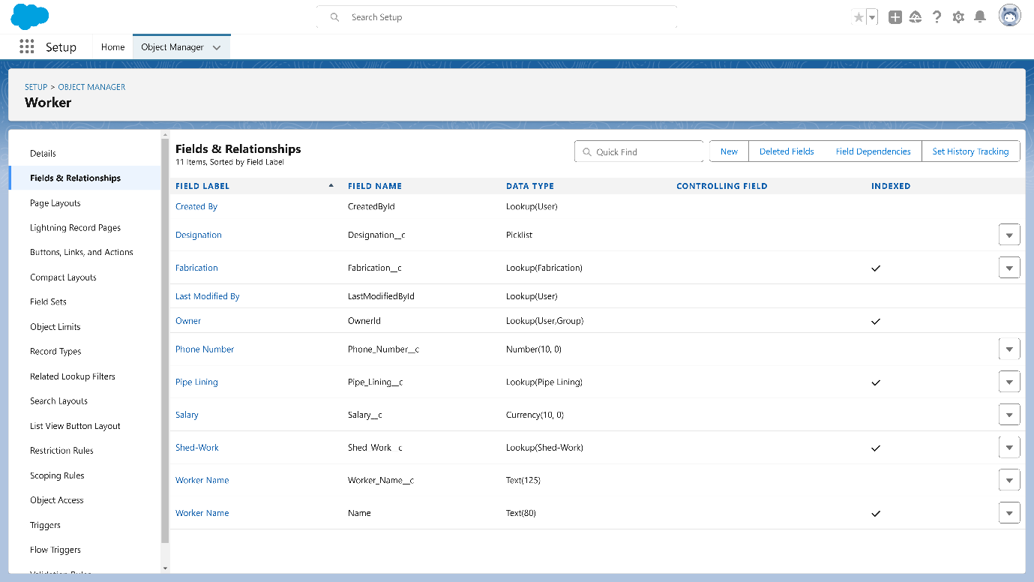

**Creation of Page Layouts:**

**Steps to Create a Page Layout in Fabrication Object for Drilling**

1. **Navigate to Setup Page**
   * Go to Setup.
2. **Access Object Manager**
   * Click on Object Manager.
   * From the dropdown, select Fabrication Object.
   * Click Edit for Fabrication Object.
3. **Create New Page Layout**
   * Click on Page Layouts.
   * Select New to create a new page layout.
4. **Enter Page Layout Details**
   * Page Layout Name: Enter "Drilling Page Layout".
   * Click on Save.
5. **Customize the Layout**
   * Drag and arrange the fields as desired for the Drilling Page Layout.
6. **Save the Layout**
   * Once the fields are arranged, click Save.

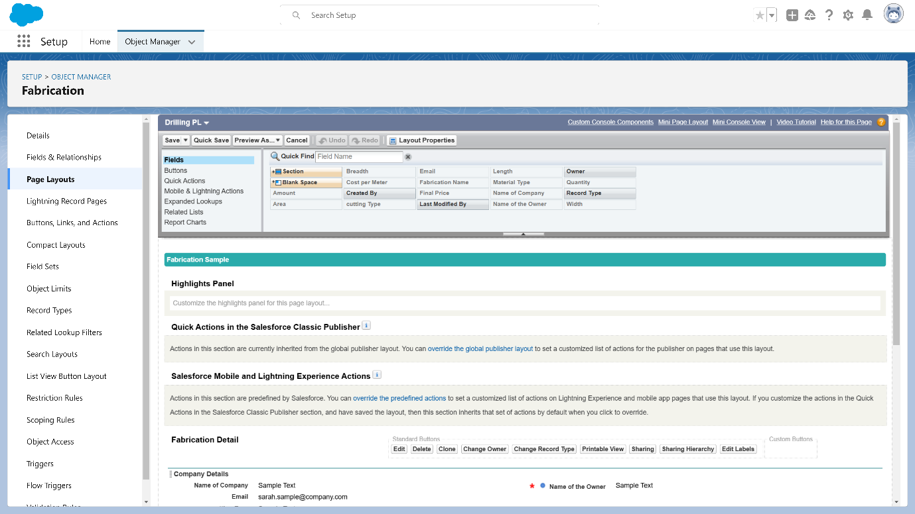

**Steps to Create a Page Layout in Fabrication Object for Welding**

1. **Navigate to Setup Page**
   * Go to Setup.
2. **Access Object Manager**
   * Click on Object Manager.
   * From the dropdown, select Fabrication Object.
   * Click Edit for Fabrication Object.
3. **Create New Page Layout**
   * Click on Page Layouts.
   * Select New to create a new page layout.
4. **Enter Page Layout Details**
   * Page Layout Name: Enter "Welding Page Layout".
   * Click on Save.
5. **Customize the Layout**
   * Drag and arrange the fields as desired for the Welding Page Layout.
6. **Save the Layout**
   * Once the fields are arranged, click Save.

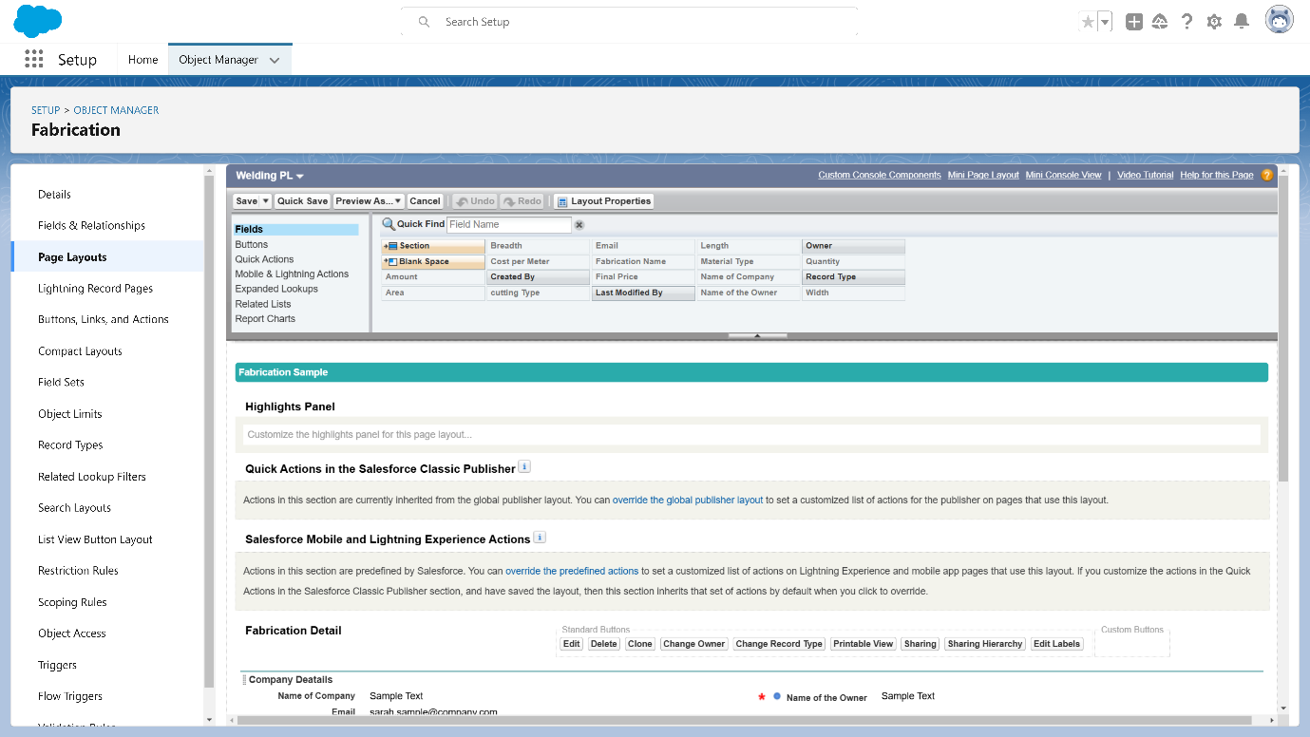

**Steps to Create a Page Layout in Fabrication Object for Cutting**

1. **Navigate to Setup Page**
   * Go to **Setup**.
2. **Access Object Manager**
   * Click on **Object Manager**.
   * From the dropdown, select **Fabrication Object**.
   * Click **Edit** for Fabrication Object.
3. **Create New Page Layout**
   * Click on **Page Layouts**.
   * Select **New** to create a new page layout.
4. **Enter Page Layout Details**
   * **Page Layout Name**: Enter "Cutting Page Layout".
   * Click on **Save**.
5. **Customize the Layout**
   * Drag and arrange the fields as desired for the Cutting Page Layout.
6. **Save the Layout**
   * Once the fields are arranged, click **Save**.

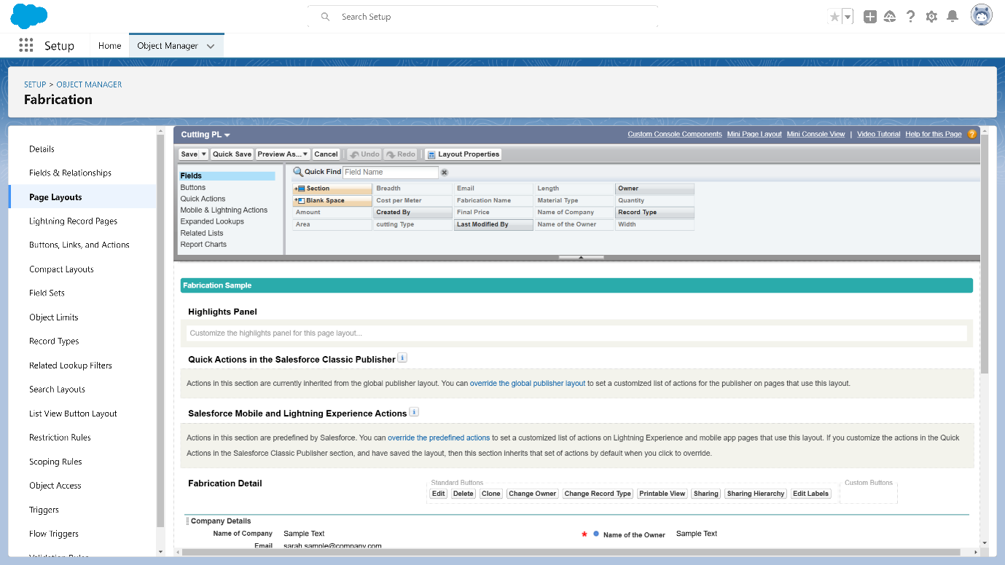

**Steps to Create a Page Layout in Fabrication Object for Folding**

1. **Navigate to Setup Page**
   * Go to **Setup**.
2. **Access Object Manager**
   * Click on **Object Manager**.
   * From the dropdown, select **Fabrication Object**.
   * Click **Edit** for Fabrication Object.
3. **Create New Page Layout**
   * Click on **Page Layouts**.
   * Select **New** to create a new page layout.
4. **Enter Page Layout Details**
   * **Page Layout Name**: Enter "Folding Page Layout".
   * Click on **Save**.
5. **Customize the Layout**
   * Drag and arrange the fields as desired for the Folding Page Layout.
6. **Save the Layout**
   * Once the fields are arranged, click **Save**.

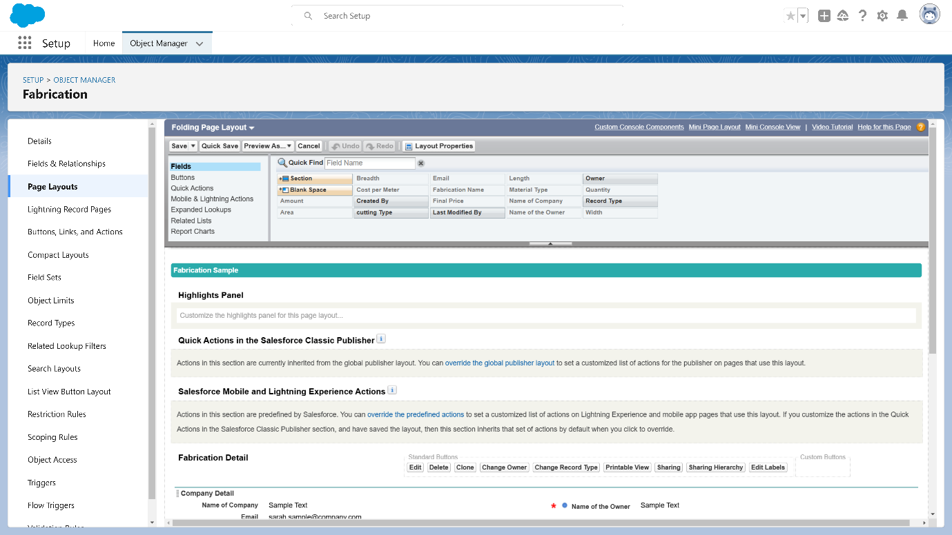

**Creation of Record Types:**

**Steps to Create a Record Type in Fabrication Object for Drilling**

1. **Navigate to Setup Page**
   * Go to Setup.
2. **Access Object Manager**
   * Click on Object Manager.
   * From the dropdown, select Fabrication Object.
   * Click Edit for Fabrication Object.
3. **Create New Record Type**
   * Click on Record Types.
   * Select New to create a new record type.
4. **Enter Record Type Details**
   * Existing Record Types: Choose Master.
   * Record Type Label: Enter "Drilling".
   * Record Type Name: Enter "Drilling".
   * Active: Tick the checkbox to make it active.
   * Click on Next.
5. **Assign Page Layout**
   * Apply one layout to all profiles: Select Drilling Page Layout.
   * Click on Save.

**Repeat Steps for Additional Record Types**

Repeat the above steps to create Record Types for Welding, Cutting, and Folding using their respective page layouts:

* Record Type Label: Enter the name (e.g., "Welding", "Cutting", or "Folding").
* Record Type Name: Enter the name (same as the label).
* Apply one layout to all profiles: Select the corresponding page layout (e.g., Welding Page Layout, Cutting Page Layout, or Folding Page Layout).

**Validation rule**

**Steps to Create a Validation Rule in Fabrication Object**

1. **Navigate to Setup Page**
   * Go to Setup.
2. **Access Object Manager**
   * Click on Object Manager.
   * From the dropdown, select Fabrication Object.
   * Click Edit for Fabrication Object.
3. **Create New Validation Rule**
   * Click on Validation Rules.
   * Select New to create a new validation rule.
4. **Enter Validation Rule Details**
   * Rule Name: Enter "Rule_for_fabrication".
   * Error Condition Formula: Enter the following formula: OR(Length__c == 0, Breadth__c == 0, Width__c == 0, Quantity == 0)
   * Error Message: Enter "Length, Breadth, Width, and Quantity values should not be zero."
   * Error Location: Select Top of Page.
5. **Save the Validation Rule**
   * Click Save.

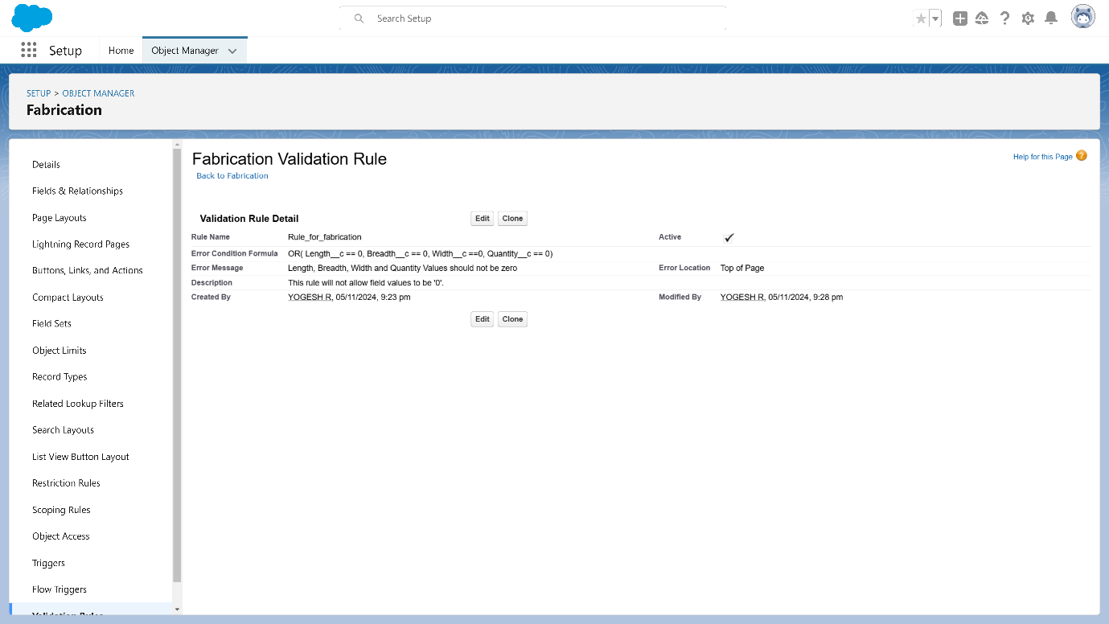

**Steps to Create a Validation Rule in Shed-Work Object**

1. **Navigate to Setup Page**
   * Go to **Setup**.
2. **Access Object Manager**
   * Click on **Object Manager**.
   * From the dropdown, select **Shed-Work Object**.
   * Click **Edit** for Shed-Work Object.
3. **Create New Validation Rule**
   * Click on **Validation Rules**.
   * Select **New** to create a new validation rule.
4. **Enter Validation Rule Details**
   * **Rule Name**: Enter "Rule_for_shed_work".
   * **Error Condition Formula**: Enter the following formula: OR(Length__c == 0, Breadth__c == 0, Width__c == 0, Quantity == 0)
   * **Error Message**: Enter "Length, Breadth, Width, and Quantity values should not be zero."
   * **Error Location**: Select **Top of Page**.
5. **Save the Validation Rule**
   * Click **Save**.

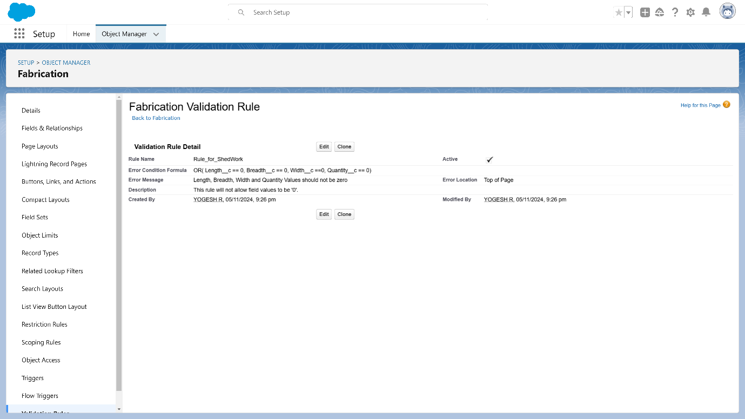

**Steps to Create a Validation Rule in Pipe Lining Object**

1. **Navigate to Setup Page**
   * Go to **Setup**.
2. **Access Object Manager**
   * Click on **Object Manager**.
   * From the dropdown, select **Pipe Lining Object**.
   * Click **Edit** for Pipe Lining Object.
3. **Create New Validation Rule**
   * Click on **Validation Rules**.
   * Select **New** to create a new validation rule.
4. **Enter Validation Rule Details**
   * **Rule Name**: Enter "Rule_for_pipe_lining".
   * **Error Condition Formula**: Enter the following formula: OR(Length__c == 0, Breadth__c == 0, Width__c == 0, Quantity == 0)
   * **Error Message**: Enter "Length, Breadth, Width, and Quantity values should not be zero."
   * **Error Location**: Select **Top of Page**.
5. **Save the Validation Rule**
   * Click **Save**.

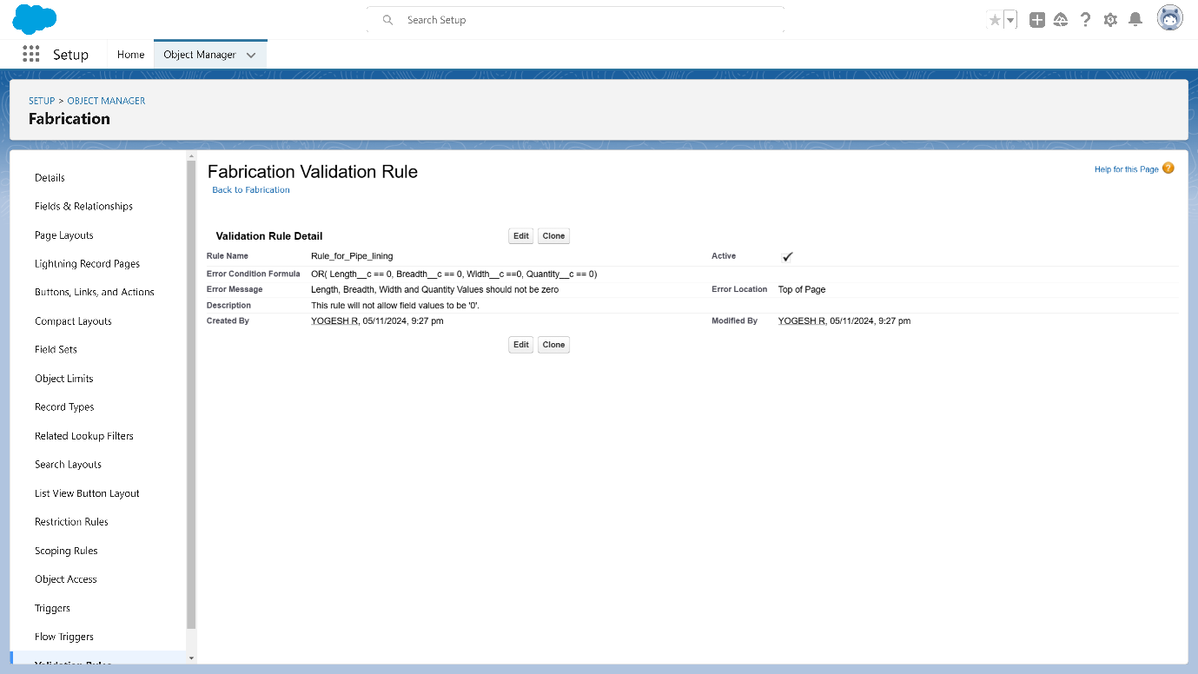

**Email Templates:**

**Upload Logo into Salesforce**

1. Go to the setup page >> In quick find box search for Salesforce  Branding >> Click on Edit.
2. In Loading Page Logo >> Choose File >> Select the image and click open >> Click on Save.

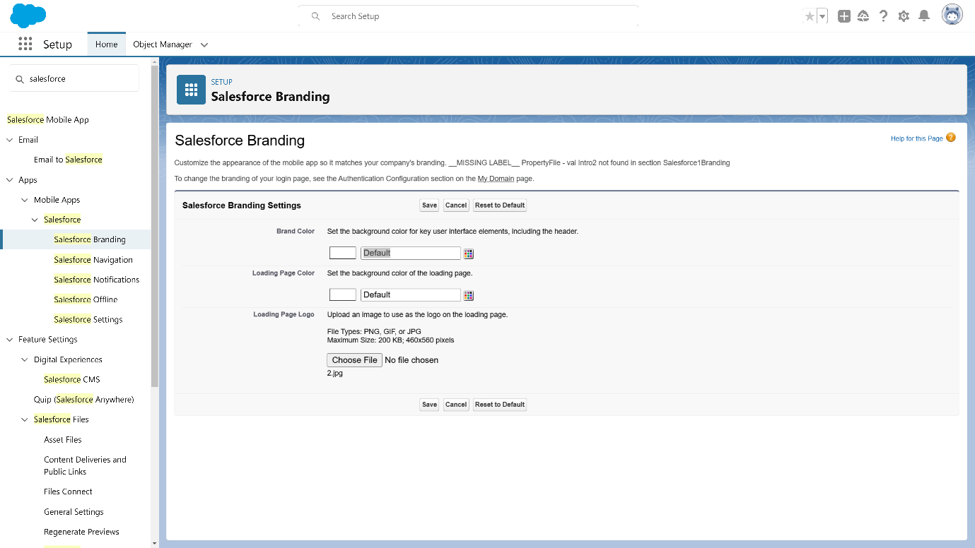

**Creation of Letterhead for Email purpose.**

1. Go to the setup page >> In quick find box search for Classic Letterheads >> Click on New Letterhead.
2. Check Available for use box.
3. Letterhead Label : Letterhead for Email Purpose
4. Letterhead Unique Name : Auto-populated
5. Click on Save >> Now click on Letterhead for Email Purpose then Edit Letterhead.
6. Click on select logo >> Now select the logo and click save.

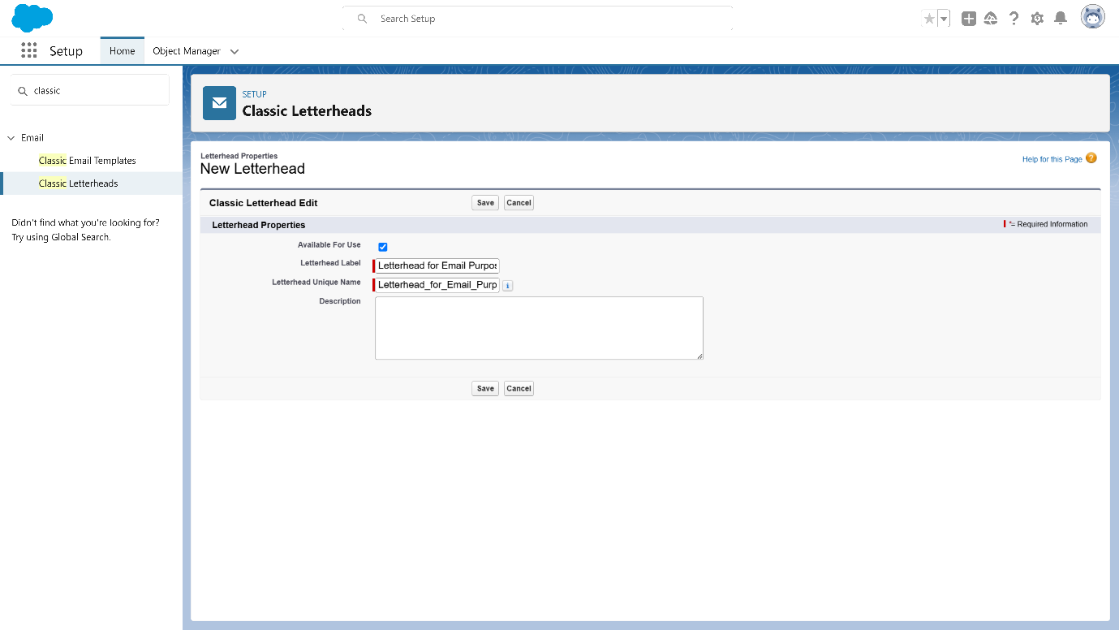

**Steps to Create an Email Template in Fabrication Object**

1. **Navigate to Setup Page**
   * Go to **Setup**.
   * In the Quick Find box, enter **Email Template** and click on **Classic Email Templates**.
2. **Create a New Email Template**
   * Click on **New Email Template**.
   * Choose **HTML (using Classic Letterhead)**.
3. **Enter Email Template Details**
   * **Folder**: Select **Unfiled Public Classic Email Templates**.
   * **Available for Use**: Check this box.
   * **Email Template Name**: Enter "Bill Template".
   * **Template Unique Name**: This field will be auto-populated.
   * **Subject**: Enter "Fabrication Template".
4. **Compose Email Body**
   * **Email Body**:

Hello {!Fabrication__c.Name_of_the_Owner__c} {!Shed_Work__c.Name_of_the_Owner__c} {!Pipe_Lining__c.Name_of_Owner__c},

I hope everything is going well in {!Fabrication__c.Name_of_Company__c} {!Shed_Work__c.Name_of_Company__c} {!Pipe_Lining__c.Name_of_Company__c} Company. I have attached the required items for the work to be done. Please verify them.

Length = {!Fabrication__c.Length__c} {!Shed_Work__c.Height__c} {!Pipe_Lining__c.Height__c}, breadth = {!Fabrication__c.Length__c} {!Shed_Work__c.Breadth__c}, width = {!Fabrication__c.Width__c} {!Shed_Work__c.Width__c} {!Pipe_Lining__c.Width__c}, area = {!Fabrication__c.Area__c} {!Shed_Work__c.Area__c} {!Pipe_Lining__c.Area__c}, The Final Price = {!Fabrication__c.price__c} {!Shed_Work__c.Price__c} {!Pipe_Lining__c.Price__c}.

Thanks & Regards,

Engineering Works.

1. **Save the Template**
   * Click **Save**.

**Steps to Create an Email Template for Shed-Work Object**

1. **Repeat the Above Steps**:
   * Follow the same steps to create a new email template with details relevant to the **Shed-Work** object.
2. **Customize the Email Body**:
   * Adjust the merge fields to pull data from **Shed-Work** object fields, if needed.

**Steps to Create an Email Template for Pipe Lining Object**

1. **Repeat the Above Steps**:
   * Follow the same steps to create a new email template with details relevant to the **Pipe Lining** object.
2. **Customize the Email Body**:
   * Adjust the merge fields to pull data from **Pipe Lining** object fields, if needed.

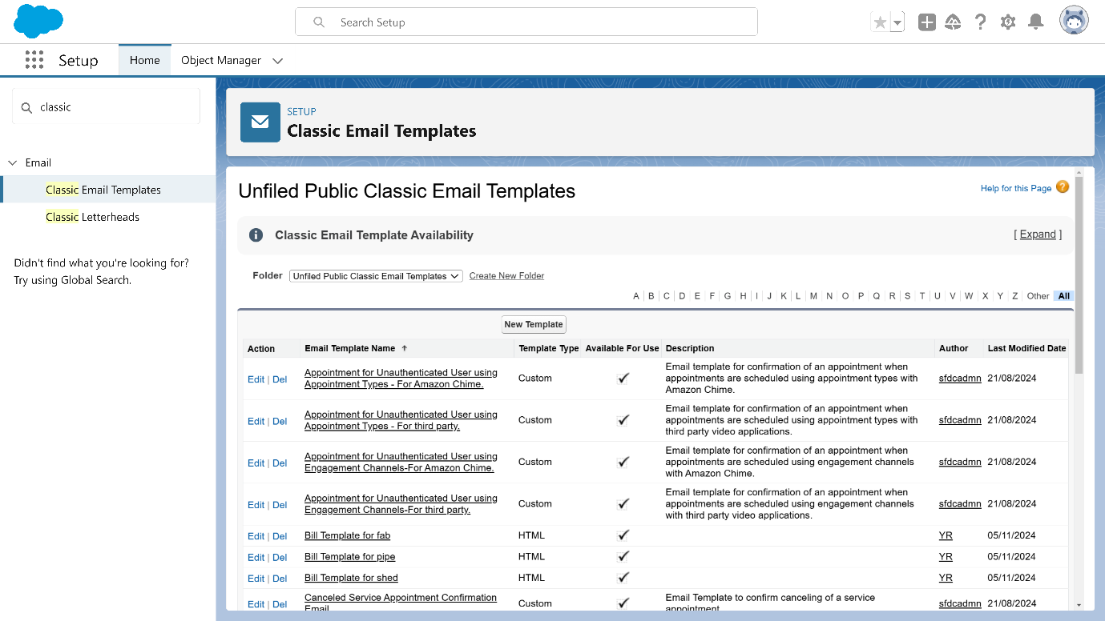

**Steps to Create an Email Alert for Fabrication Object**

1. **Navigate to Setup Page**
   * Go to **Setup**.
   * In the Quick Find box, enter **Email Alert** and select **Email Alerts**.
2. **Create New Email Alert**
   * Click on **New Email Alert**.
3. **Enter Email Alert Details**
   * **Description**: Enter "Email Alert for Fabrication Object".
   * **Unique Name**: This field will be auto-populated.
   * **Object**: Select **Fabrication**.
   * **Email Template**: Select the **Bill Template** created for the Fabrication Object.
4. **Add Recipients**
   * **Recipients**: Add the following users:
     + **User: Integration User**
     + **User: System Administrator**
     + **User: Security User**
5. **Save the Email Alert**
   * Click **Save**.

Similarly create for Pipe-Lining and Shed-Work objects

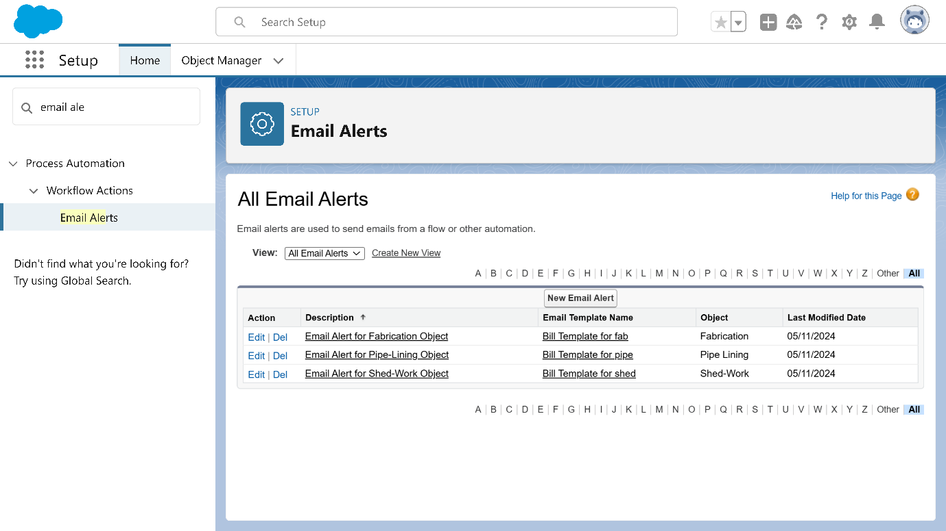

**FLOWS:**

**Steps to Create the Flow for Final Price Calculation**

1. **Go to Setup Page**
   * Go to **Setup**.
   * In the Quick Find box, enter **Flow** and click on **Flows**.
   * Click **New Flow**.
2. **Create a Record-Triggered Flow**
   * Select **Record-Triggered Flow**.
   * Click **Create**.
3. **Set Object and Trigger Conditions**
   * Under **Object**, select **Fabrication**.
   * Set the Trigger to **A record is created or updated**.
   * Set **Entry Conditions** to **None**.
4. **Select Actions and Related Records**
   * Click the **+** icon under **Record Trigger Flow** and select **Send Email Alert**.
   * In **New Action**, select the **Fabrication Template**.
   * **Label**: Enter "Mail".
   * **API Name**: Enter "Mail".
   * **Record ID**: Select **{!$Record.Id}**.
   * Click **Done**.
5. **Add Decision Node for Material Types**
   * Click the **+** icon under **Record Trigger Flow** and select **Decision**.
   * For **New Decision**:
     + **Label**: Enter "Material".
     + **API Name**: Enter "Material".
   * **Outcome 1**:
     + **Label**: "Iron Material".
     + **API Name**: "Iron_Material".
     + **Condition**: {!$Record.Material_Type__c} **Equals** "Iron".
   * Repeat the steps for **Aluminum**, **Metal**, **Wood**, and **Steel** outcomes, setting the corresponding material value.
6. **Add Actions for Each Material Type**
   * Under each material outcome (e.g., **Iron Material**, **Aluminum**, **Metal**, etc.), click on the **+** icon and select **Update Related Record**.
   * For **Iron**:
     + **Label**: "For Iron".
     + **API Name**: "For_Iron".
     + **How to Find Records to Update**: Select "Use the fabrication record that triggered the flow".
     + Set **Final_price__c** field:
       - **Formula**: {!$Record.Amount__c} * 2 (adjust for each material type with different multipliers)
   * Repeat for **Aluminum**, **Metal**, **Wood**, and **Steel**, updating the **Final_price__c** field with respective multipliers:
     + **Aluminum**: {!$Record.Amount__c} * 1.8
     + **Metal**: {!$Record.Amount__c} * 1.6
     + **Wood**: {!$Record.Amount__c} * 1.4
     + **Steel**: {!$Record.Amount__c} * 1.2
7. **Save and Activate the Flow**
   * Click **Save**.
   * **Flow Label**: Enter "Fabrication Flow".
   * **Flow API Name**: Enter "Fabrication_Flow".
   * Click **Save** and **Activate**.

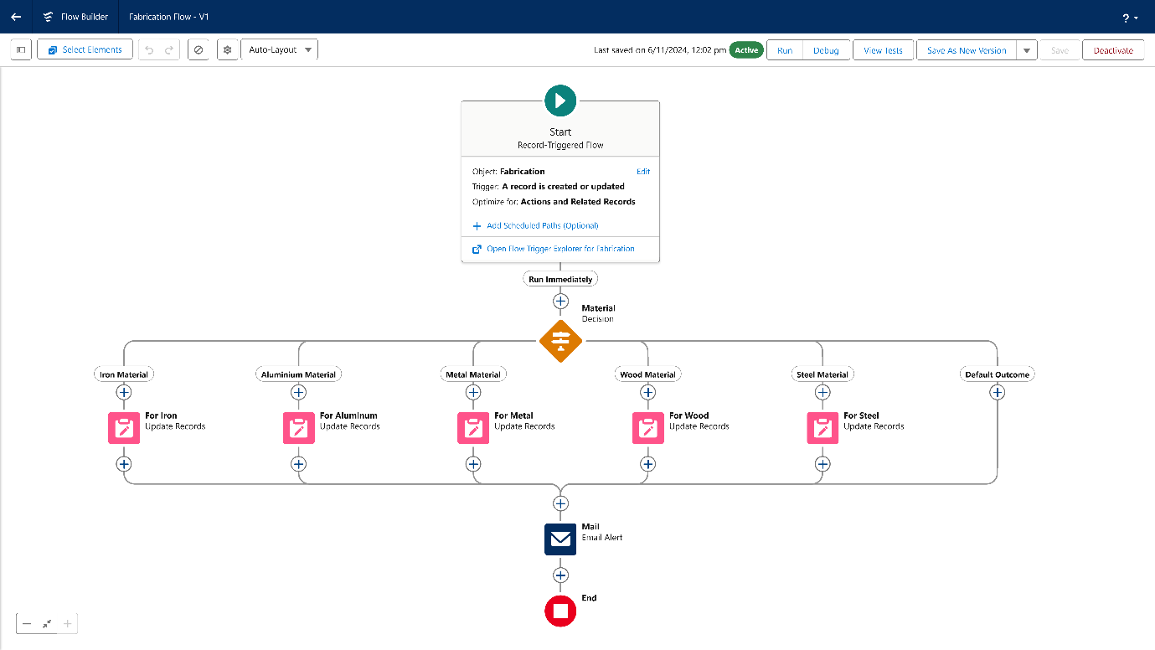

**Steps to Create a Flow to Calculate Final Price on Shed Work Object Based on Material Type**

1. **Go to Setup**
   * Type **Flow** in the Quick Find box and select **Flows**.
   * Click **New Flow**.
2. **Select Flow Type**
   * Choose **Record-Triggered Flow**.
   * Click **Create**.
3. **Configure Flow Trigger**
   * Under **Object**, select **Shed Work**.
   * Select **A record is created or updated**.
   * Set **Entry Conditions** to **None**.
4. **Add Actions and Related Records**
   * Click the **+** icon under **Record Trigger Flow** and select **Send Email Alert**.
   * In **New Action**, select **Fabrication Template**.
   * **Label**: "Mail".
   * **API Name**: "Mail".
   * **Record ID**: Select **{!$Record.Id}**.
   * Click **Done**.
5. **Add Decision Node for Material Type**
   * Click the **+** icon under **Record Trigger Flow** and select **Decision**.
   * **Label**: "Material".
   * **API Name**: "Material".
   * Add outcomes based on the **Material_Type__c** field:
     + **Iron**: Value = "Iron"
     + **Metal1**: Value = "Metal"
     + **Steel**: Value = "Steel"
   * Click **Done**.
6. **Add Actions to Update Final Price for Each Material Type**
   * For **Iron** outcome:
     + Click **+** and select **Update Related Record**.
     + **Label**: "For Iron".
     + **API Name**: "For_Iron".
     + Select **Use the Shed Work record that triggered the flow**.
     + Set **Field**: **Final_price__c**.
     + **Formula**: {!$Record.Amount__c} * 2.
     + Click **Done**.
   * For **Metal1** outcome:
     + Click **+** and select **Update Related Record**.
     + **Label**: "For Metal1".
     + **API Name**: "For_Metal1".
     + Set **Formula**: {!$Record.Amount__c} * 1.8.
     + Click **Done**.
   * For **Steel** outcome:
     + Click **+** and select **Update Related Record**.
     + **Label**: "For Steel".
     + **API Name**: "For_Steel".
     + Set **Formula**: {!$Record.Amount__c} * 1.5.
     + Click **Done**.
7. **Add Decision Node for Sheet Material Types**
   * Click **+** (between the first decision and the email alert) and select **Decision**.
   * **Label**: "Sheet Material".
   * **API Name**: "Sheet_Material".
   * Add outcomes for:
     + **Metal2**: Value = "Metals".
     + **Rubber**: Value = "Rubber".
     + **Plastic**: Value = "Plastic".
   * Click **Done**.
8. **Add Actions to Update Final Price for Sheet Material Types**
   * For **Metal2** outcome:
     + Click **+** and select **Update Related Record**.
     + **Label**: "For Metal2".
     + **API Name**: "For_Metal2".
     + Set **Formula**: {!$Record.Amount__c} * 1.8.
     + Click **Done**.
   * For **Rubber** outcome:
     + Click **+** and select **Update Related Record**.
     + **Label**: "For Rubber".
     + **API Name**: "For_Rubber".
     + Set **Formula**: {!$Record.Amount__c} * 1.8.
     + Click **Done**.
   * For **Plastic** outcome:
     + Click **+** and select **Update Related Record**.
     + **Label**: "For Plastic".
     + **API Name**: "For_Plastic".
     + Set **Formula**: {!$Record.Amount__c} * 1.5.
     + Click **Done**.
9. **Save and Activate the Flow**
   * Click **Save**.
   * **Flow Label**: "Shed Work Flow".
   * **Flow API Name**: "Shed_Work_Flow".
   * Click **Save** and then **Activate**.

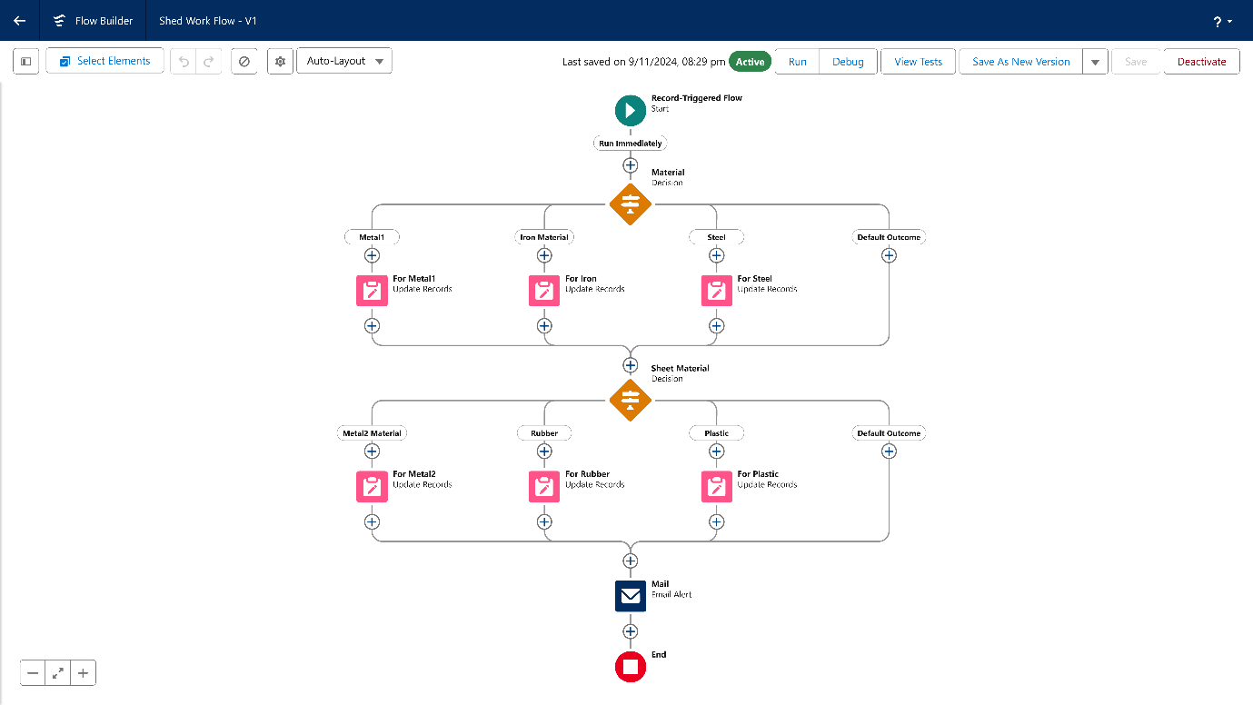

**Steps to Create a Flow to Calculate Final Price on Pipe Lining Object Based on Material Type**

1. **Go to Setup**
   * Type **Flow** in the Quick Find box and select **Flows**.
   * Click **New Flow**.
2. **Select Flow Type**
   * Choose **Record-Triggered Flow**.
   * Click **Create**.
3. **Configure Flow Trigger**
   * Under **Object**, select **Pipe Lining**.
   * Select **A record is created or updated**.
   * Set **Entry Conditions** to **None**.
4. **Add Actions and Related Records**
   * Click the **+** icon under **Record Trigger Flow** and select **Send Email Alert**.
   * In **New Action**, select **Pipe Lining Template**.
   * **Label**: "Mail".
   * **API Name**: "Mail".
   * **Record ID**: Select **{!$Record.Id}**.
   * Click **Done**.
5. **Add Decision Node for Material Type**
   * Click the **+** icon under **Record Trigger Flow** and select **Decision**.
   * **Label**: "Material".
   * **API Name**: "Material".
   * Add outcomes based on the **Material_Type__c** field:
     + **Iron**: Value = "Iron".
     + **Aluminum**: Value = "Aluminum".
     + **Metal**: Value = "Metal".
     + **Steel**: Value = "Steel".
   * Click **Done**.
6. **Add Actions to Update Final Price for Each Material Type**
   * For **Iron** outcome:
     + Click **+** and select **Update Related Record**.
     + **Label**: "For Iron".
     + **API Name**: "For_Iron".
     + Select **Use the Pipe Lining record that triggered the flow**.
     + Set **Field**: **Final_price__c**.
     + **Formula**: {!$Record.Amount__c} * 2.
     + Click **Done**.
   * For **Aluminum** outcome:
     + Click **+** and select **Update Related Record**.
     + **Label**: "For Aluminum".
     + **API Name**: "For_Aluminum".
     + Set **Formula**: {!$Record.Amount__c} * 1.8.
     + Click **Done**.
   * For **Metal** outcome:
     + Click **+** and select **Update Related Record**.
     + **Label**: "For Metal".
     + **API Name**: "For_Metal".
     + Set **Formula**: {!$Record.Amount__c} * 1.5.
     + Click **Done**.
   * For **Steel** outcome:
     + Click **+** and select **Update Related Record**.
     + **Label**: "For Steel".
     + **API Name**: "For_Steel".
     + Set **Formula**: {!$Record.Amount__c} * 1.4.
     + Click **Done**.
7. **Save and Activate the Flow**
   * Click **Save**.
   * **Flow Label**: "Pipe Lining Flow".
   * **Flow API Name**: "Pipe_Lining_Flow".
   * Click **Save** and then **Activate**.

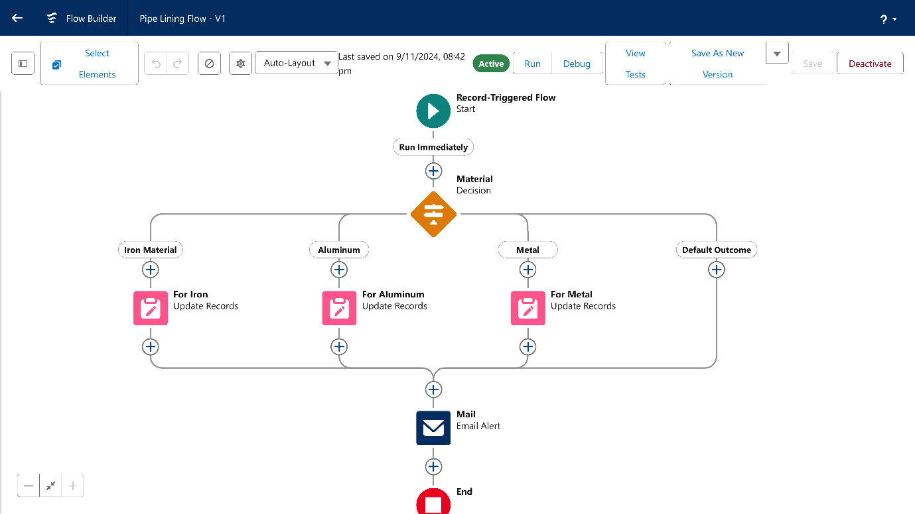

**Key Scenarios Addressed by Salesforce in the Implementation Project**

Salesforce, as a cloud-based CRM platform, offers a wide range of features that are highly beneficial in managing engineering works projects. In your CRM application for engineering works, Salesforce addresses several critical scenarios that improve project efficiency, enhance client relationships, and streamline task management. Below are key scenarios that Salesforce addresses:

**1. Centralized Data Management**

* Scenario: Engineering projects often involve various stakeholders such as clients, contractors, workers, and suppliers, which means handling large amounts of data. This data is often spread across different systems, leading to inefficiencies, errors, and delays.
* Solution: Salesforce provides a centralized platform where all project-related data (client information, materials, workers, schedules, costs, etc.) is stored in one place. This allows for quick and easy access to information by different users, ensuring everyone is on the same page.
* Outcome: By centralizing data, Salesforce eliminates data silos, improves collaboration, and reduces the time spent searching for or verifying project details.

**2. Client Relationship Management (CRM)**

* Scenario: In the engineering industry, maintaining strong client relationships is essential. Managing communication, tracking client needs, and keeping clients informed on project progress can become overwhelming without an organized system.
* Solution: Salesforce offers tools such as Contact Management, Case Management, and Communication Tools that help track every interaction with clients. You can maintain detailed records of client communications, preferences, and project-specific requirements.
* Outcome: Salesforce enhances client satisfaction by providing timely updates and personalized service. Project managers can easily monitor project progress, address client concerns, and foster stronger long-term relationships.

**3. Project Workflow Automation**

* Scenario: Engineering projects involve complex workflows, including task assignments, material procurement, labor management, and approvals. Manually managing these workflows can lead to delays, missed deadlines, and inefficiencies.
* Solution: With Salesforce’s Process Builder, Flow Builder, and Workflow Rules, you can automate several project management tasks. These tools allow automatic assignment of tasks to workers, alerts for upcoming deadlines, and approval processes for project milestones.
* Outcome: Workflow automation reduces manual efforts, speeds up task execution, and minimizes human errors, leading to on-time and efficient project completion.

**4. Material and Cost Management**

* Scenario: Accurate tracking of materials and costs is crucial in construction-related projects to ensure that resources are allocated effectively and budgets are adhered to. Without a clear system, material shortages or cost overruns can occur.
* Solution: Salesforce can automate material tracking by associating materials with specific tasks and projects. Custom objects can be created to track material usage, quantities, and costs. Salesforce’s integration with other tools, such as pricing calculators, allows automatic cost estimation based on material quantities, worker hours, and other parameters.
* Outcome: The system helps prevent material shortages and cost overruns by providing real-time updates on material usage, keeping track of costs, and providing accurate cost estimates.

**5. Task and Worker Management**

* Scenario: Coordinating tasks between workers, tracking their productivity, and ensuring that the right people are assigned to the right tasks is a challenge in project management. This can lead to project delays and inefficiencies if not managed well.
* Solution: Salesforce provides tools to track worker assignments, skillsets, and work hours through custom objects like the "Worker" object. It allows project managers to assign tasks based on worker skills and availability, monitor performance, and adjust assignments as necessary.
* Outcome: Worker management in Salesforce ensures optimal resource utilization, improved productivity, and more efficient task execution, reducing the likelihood of delays.

**6. Real-Time Reporting and Dashboards**

* Scenario: Project managers need to constantly monitor the status of ongoing projects, track expenses, and assess resource utilization. Without real-time visibility, it’s difficult to make informed decisions and take corrective actions on time.
* Solution: Salesforce provides powerful reporting and dashboard tools that allow project managers to create custom reports and track key performance indicators (KPIs) in real-time. These reports can include metrics such as material usage, cost analysis, project completion status, and worker productivity.
* Outcome: With real-time reporting and dashboards, decision-makers can access actionable insights, spot issues early, and make adjustments to ensure the project stays on track and within budget.

**7. Security and Permissions Management**

* Scenario: Engineering projects often involve sensitive information, including client data, financial details, and proprietary project information. Managing access to this data is critical to maintaining confidentiality and complying with regulations.
* Solution: Salesforce offers robust security features, such as Role-Based Access Control (RBAC), user profiles, and permission sets. These features ensure that only authorized users can access sensitive project data. For example, workers may have limited access to material information, while project managers may have full access to financials and client details.
* Outcome: With Salesforce’s security features, you ensure that sensitive data is protected, and only those with appropriate access rights can view or modify project details, reducing the risk of data breaches.

**8. Seamless Collaboration**

* Scenario: Engineering projects involve multiple stakeholders working in different teams, including engineers, construction workers, and clients. Without a collaborative system, communication gaps can occur, leading to misunderstandings or missed tasks.
* Solution: Salesforce provides tools like Chatter (a social collaboration tool), where team members can communicate, share updates, and collaborate on tasks within the system. You can tag people, share files, and update the team on project milestones.
* Outcome: Enhanced collaboration leads to faster problem resolution, better coordination, and fewer misunderstandings, ensuring that projects are completed on time and to client satisfaction.

**9. Mobile Accessibility**

* Scenario: Engineering projects are often conducted at various locations, making it difficult for managers and workers to access project data while away from the office.
* Solution: Salesforce’s mobile app enables workers and project managers to access key project data, update tasks, and communicate with team members from any device. Workers can log their hours, mark tasks as completed, and report any issues directly from the field.
* Outcome: Mobile accessibility ensures that stakeholders can stay connected and up-to-date on project progress no matter where they are, reducing delays and improving response times.

**Conclusion:**

This Engineering Works Project automates the calculation of area whenever a record is created or updated, utilizing parameters such as length, breadth, and width, as well as quantity and cost per meter. The final amount is then determined based on the area and material type.

The implementation of Salesforce in the CRM application for engineering works significantly improves the management of projects, from client interactions to task tracking and cost management. By leveraging Salesforce’s robust CRM features, such as centralized data management, task automation, real-time reporting, and mobile access, engineering companies can streamline their operations, reduce inefficiencies, and increase client satisfaction.

Key scenarios such as client relationship management, project workflow automation, material cost management, and real-time collaboration are addressed effectively with Salesforce. Furthermore, the platform’s security features and permission management ensure that sensitive data remains protected, while customizable reporting tools provide valuable insights for decision-making. With Salesforce, engineering projects can be managed more efficiently, deadlines can be met, costs can be optimized, and clients can be kept informed and satisfied throughout the project lifecycle.

In summary, Salesforce provides a comprehensive and scalable solution for managing engineering works projects. Its ability to automate workflows, track tasks, and manage resources ensures that projects are executed efficiently, improving both operational performance and client satisfaction. By integrating Salesforce into the engineering work process, businesses can unlock new levels of productivity, collaboration, and profitability.